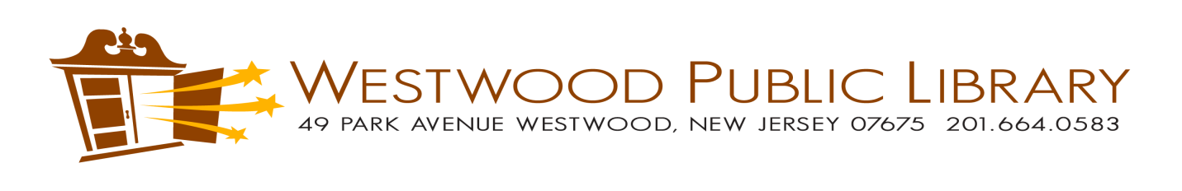
CIRCULATION POLICY

Library Cards

A valid library card must be presented to borrow materials. All Westwood residents are eligible for a library card.

In order to register for a card, valid identification with a Westwood address is required. Driver’s license or utility bills are accepted as ID.

Patrons must renew their cards every three years by showing Westwood identification. There is no charge to replace lost cards.

If you work in Westwood but do not live in area served by BCCLS, you may be eligible for a courtesy library card. If you live in a town not served by any library, you may purchase a library card. Please contact the library for further details.

Please note, cards will be blocked if registration expires, $10 or more in fines are on card, or card has an outstanding number of overdue materials.

Borrowing and Loan Period

Lending Regulations:
All library materials circulate free of charge to valid library card holders.

Library materials have different circulation periods and renewal times. The library will supply check out slips with due dates posted for each item borrowed, borrowers can access their cards online at any time, and borrowers may email or call the Library during open hours to check due dates. Borrowers are responsible for knowing the due dates of their materials.

Eligible items can be renewed by phone, by email or in person. Items can also be renewed online through borrower’s account.

Borrower is financially responsible for all materials and will be charged for late, lost or damaged items. Parents or guardians are financially responsible for all materials checked out by their children.

Borrower agrees to abide by the copyright provision in Title 17, US Code, Section 501-506.
This institution will not be held financially liable for any damage to any equipment used to run materials obtained from the Library.

Circulation and Renewals

Item | Check Out | Renewals | Fines
Adult Books | 4 weeks | 4 | .15/day
Large Print | 4 weeks | 4 | .15/day
Children's Books | 4 weeks | 4 | .15/day
New Adult Books | 2 weeks | 4 | .30/day
Audio Books | 2 weeks | 4 | .15/day
Music CDs | 2 weeks | 4 | .15/day
Periodicals | 1 week | 1 | .15/day
Children's Holiday Books | 2 weeks | 4 | .15/day
Summer Reading Books | 2 weeks | 0 | .15/day
Non Fic DVDS/TV DVDs | 2 weeks | 4 | 1.00/day
DVDs | 1 week | 1 | 1.00/day
Walk In Books | 1 week | 0 | 1.00/day
Walk In DVDs | 3 days | 0 | 1.00/day
Video Games | 2 weeks | 4 | 1.00/day

Maximum Overdue Fines:
Hardcover Books, Paperback Books, DVDs, Audiobooks, Children’s Hardcover: $10.00
Periodicals: $5.00
Children’s Paperbacks: $5.00
All Other Materials: $10.00
Other Fines:
Damaged DVD Cover: $1.00
Lost or Replacement Costs:
Borrowers are responsible for paying the Library assigned replacement cost for lost or damaged items.

**Walk-in Collection is comprised of duplicate copies of very popular books and DVDs. Copies of all items in the Walk-in Collection are also in our regular collection and have a normal circulation period.
Reserves:
All Library Material may be reserved on the computer, by phone or in person. (Exception: Walk-In Collection cannot be reserved.)
Inter-Library Loans:
Patrons of the Westwood Public Library can request materials from any BCCLS Library through the catalog, by phone or in person. They may also request materials from outside of BCCLS through the State Library by calling or visiting the Westwood Library.
Approved by the Westwood Public Library Board of Trustees June 2015

