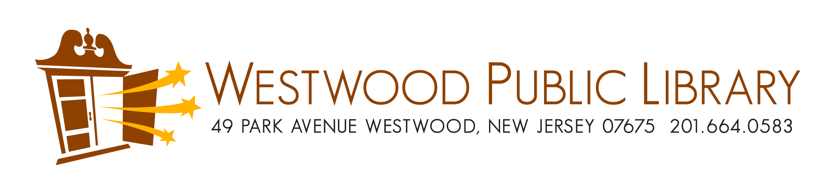
EQUIPMENT LENDING AGREEMENT

I,____________________________ am requesting to borrow the equipment listed below on behalf of (organization/family name)____________________.

Address:________________________________________________________
Phone:_________________________________________________________
Email:__________________________________________________________

Equipment:______________________________________________________

The equipment will be picked up (date/time):___________________________
The equipment will be returned (date/time):____________________________

If any of the borrowed equipment is lost, damaged or destroyed, I agree to replace it by comparable equipment or by the replacement cost, to be determined by the Director of the Westwood Free Public Library.

Signed:__________________________________________________________
Dated:___________________________________________________________

201.664.0583/library@westwood.bccls.org

